Project Design Phase-II
Technology Stack (Architecture & Stack)
Date | 01 October 2026
Team ID | 6ab6292ddcdae33acb3906da
Project Name | Import Data Using Transform Maps (Spreadsheet)
Maximum Marks | 4 Marks
Technical Architecture:
The architecture diagram below shows how spreadsheet data is imported into ServiceNow with a transform map and how access to it is controlled. Table 1 and Table 2 give the components and application characteristics.
Project: Importing employee training data into ServiceNow using Import Sets and Transform Maps
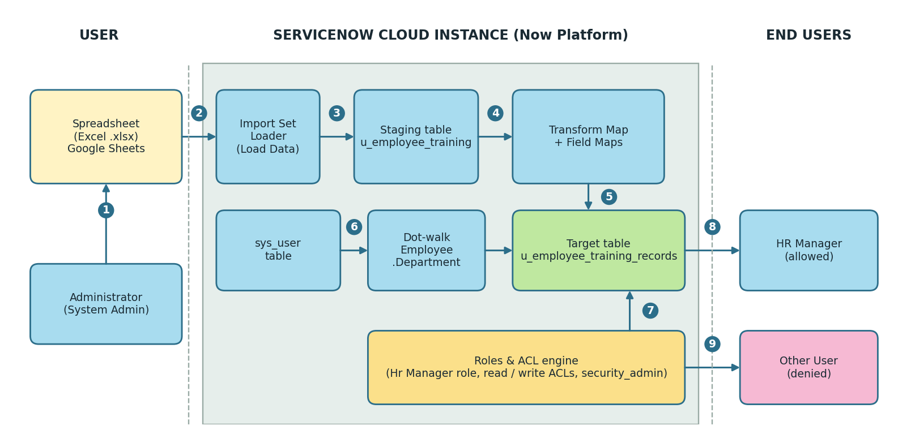
Figure 1: Technical architecture
Numbers in the diagram
- Administrator prepares the .xlsx file with Training Name, Completion Date, Status and Employee.
- The file is uploaded through Load Data (Import Set Loader).
- Rows are staged in the import set table u_employee_training.
- The transform map and its field maps process the staged rows.
- Records are inserted into the target table u_employee_training_records.
- Dot-walking reads Employee.Department from the sys_user table.
- The Roles & ACL engine checks the user's roles on every request.
- A user with the Hr Manager role can view and edit the records.
- Any other user is denied access to the table.

Table-1 : Components & Technologies:
S.No | Component | Description | Technology
1. | User Interface | Users work through the ServiceNow web UI: forms, list views, application menu and module for Employee Training Records, and the Impersonate User option for testing. | ServiceNow Next Experience (Platform UI) in a web browser
2. | Application Logic-1 (Data import) | Load Data uploads the .xlsx file (sheet 1, header row 1) and creates the import set table u_employee_training; rows are staged before they reach the real table. | ServiceNow Import Sets (Load Data, ImportProcessor)
3. | Application Logic-2 (Transform) | The transform map links the import set table to the target table; field maps connect u_training_name, u_completion_date, u_status and the employee column. Running the transform inserts the records. | ServiceNow Transform Map and Field Maps
4. | Application Logic-3 (Dot-walking) | The Employee reference field links each record to sys_user. Employee.Department is added to the form layout so the department shows on the form and in the list. | ServiceNow Form Layout (dot-walking)
5. | Application Logic-4 (Access control) | The Hr Manager role is created and assigned to a user, added to the application menu and module, and used in read and write ACLs on the table. | ServiceNow Roles, Users and Access Control (ACL)
6. | Database | Tables: u_employee_training (staging), u_employee_training_records (target; fields Training Name, Completion Date, Status [choice], Employee [reference to sys_user]) and sys_user. | ServiceNow relational tables (Table & Dictionary entries)
7. | Cloud Database | The tables above live in the database of the ServiceNow cloud instance, which ServiceNow manages. No separate database server is set up. | ServiceNow cloud instance database
8. | File Storage | The spreadsheet is created and downloaded as .xlsx, then uploaded to the instance through Load Data. No other file storage is required. | Google Sheets / Excel (.xlsx), ServiceNow attachments
9. | External API-1 | Not used. Data comes only from the uploaded spreadsheet. | Not applicable
10. | External API-2 | Not used. | Not applicable
11. | Machine Learning Model | Not used. The project is rule-based (transform map, roles, ACLs). | Not applicable
12. | Infrastructure (Server / Cloud) | Local server configuration: none; only a browser and a spreadsheet tool are needed. Cloud server configuration: a ServiceNow cloud instance (application scope: Global). | ServiceNow cloud instance
Table-2: Application Characteristics:
S.No | Characteristics | Description | Technology
1. | Open-Source Frameworks | No open-source frameworks are used. The project is built with the low-code ServiceNow platform. The spreadsheet uses the open .xlsx file format. | ServiceNow low-code platform; Office Open XML (.xlsx)
2. | Security Implementations | Role-based access: the Hr Manager role is required in read and write ACLs on u_employee_training_records and on the application menu and module. ACL changes need the security_admin role (elevated). Access was tested by impersonating users. | ServiceNow Roles, ACLs, Elevate Role, Impersonate User
3. | Scalable Architecture | Importing is split into stages (spreadsheet, staging table, target table), and the same transform map can be reused for later loads. The platform runs as a multi-tier cloud service (browser, application, database). | Import Sets and Transform Maps on the ServiceNow cloud
4. | Availability | The application runs on the ServiceNow-hosted cloud instance, so servers, backups and uptime are handled by the platform and nothing is installed locally. | ServiceNow managed cloud instance
5. | Performance | Staging lets the file load quickly before transformation. Department is read through dot-walking, so it is not copied into each record. The Employee reference points to the indexed sys_user table. | Import Set staging; dot-walking; reference field
References:
https://docs.servicenow.com
https://developer.servicenow.com
https://c4model.com/

